Bronchopulmonary Dysplasia: Information for Parents

What is bronchopulmonary dysplasia?
- Bronchopulmonary dysplasia (BPD), also called chronic lung disease (CLD), is a lung disease that can develop in babies who are born early and have breathing problems.
- Broncho means “airways or air tubes in the lungs.” Pulmonary means “air sacs in the lungs.”
- Dysplasia means “unusual changes in cells.”
- Chronic means “long term.”
- The lung tissue and airways of a premature baby are very soft and fragile. They are easily damaged and can become inflamed (swollen) and scarred.
- Once damaged, the growth of lung tissue and airways is abnormal and breathing becomes difficult.
- BPD is one of the most common lung diseases in children.

What causes BPD?
The exact cause of BPD is not known. The following are some things that make a baby more likely to develop BPD:
- BPD is most common in babies who have immature lungs. Babies born more than 10 weeks premature or weighing less than 2 pounds have the highest risk for developing BPD.
- Sometimes the very things that are needed to save the lives of preemie babies with respiratory distress syndrome (RDS) also can damage their lungs. Important treatments like oxygen and a breathing machine (ventilator) are very helpful. Sometimes a large amount of high pressure is needed to help breathing; however, the high pressure also can be harmful to fragile lung tissue.
- Lung infections like pneumonia also can cause swelling in the airways and tissue of the lungs.

What are the signs of BPD?
BPD is usually suspected when a baby is between 1 and 2 months of age and has one or more of the following:
- A baby needs extra oxygen at 36 weeks corrected gestational age (about 1 month before the due date).
- A chest X ray shows lung damage.
- Ongoing breathing problems (breathes too fast or uses extra chest muscles to breathe) are present.
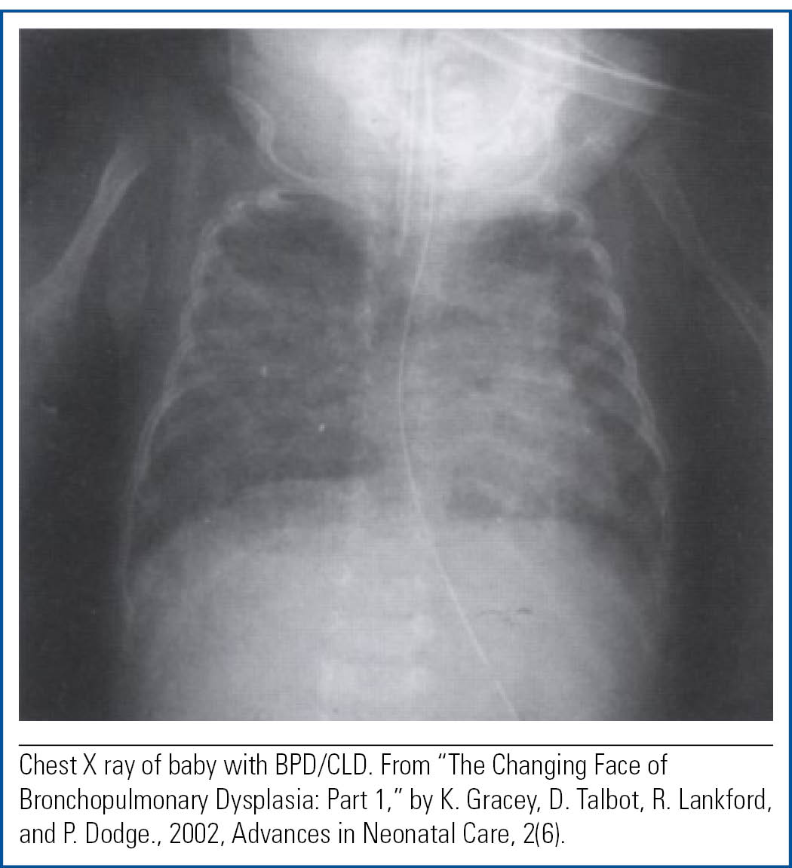

How do babies with BPD act?
Babies with BPD may have some or all of the following:
- fast, shallow, or noisy (grunting) breathing
- frequent coughing, wheezing, shortness of breath, and flaring of nostrils
- pulling of chest muscles inward between the rib spaces (retractions)
- sometimes look blue or dusky in color because of low blood oxygen levels
- need extra oxygen to grow and develop
- tire easily or breathe fast with feedings, which may slow growth and weight gain
- breathing may sound crackly or wet when listening with a stethoscope.
Is there a cure or treatment for BPD?
There is no quick cure for BPD, but there are many treatments that help babies breathe easier:
- Oxygen is used to make breathing easier and more comfortable. Some babies need to use oxygen at home. Oxygen may be needed for many weeks or months.

- Medications are sometimes used to help babies with BPD breathe easier. Surfactant and caffeine therapy in premature babies helps prevent BPD. Bronchodilators open the airways in the lungs. Corticosteroids help reduce inflammation in the lungs. Diuretics decrease fluid buildup in the lungs. Antibiotics treat bacterial lung infections, which are common in babies with BPD.
- High-calorie breast milk or formula gives your baby extra calories and nutrients to help growth and healing. Because some babies use so much energy just to breathe, they may need to be fed by a tube in the nose or stomach to make sure they take in enough calories to grow.
- Growth is the best treatment for BPD. With time, your baby will grow new, healthy lung tissue.
- In rare cases, some babies will have severe lung dam- age and need the help of a breathing machine (ventilator) for many months or more. If so, a tracheostomy is often used to help with breathing. A tracheostomy is a small hole in the neck that enables a special breathing tube to be put into the windpipe with a ventilator to support breathing.

Good News About BPD
- New devices (machines) make oxygen therapy and breathing machines more gentle on the baby’s lungs.
- Medications help make breathing easier and decrease breathing problems.
- Most babies will outgrow BPD because they rapidly grow new lung tissue during the first 2 years of life.
- Babies with BPD can usually be cared for at home in close partnership with the baby’s provider and pediatric pulmonologist. A pediatric pulmonologist is a doc- tor who specializes in the treatment of lung disease in children.

Going Home
Call your baby’s provider right away if your baby has
- breathing problems that become worse or signs of respiratory infection:
  - fever
  - breathes faster than usual
  - works harder to breathe than usual
  - coughs, wheezes, or breathes more noisily than usual
  - pale, dusky, or blue lips or fingernails
  - more irritable or fussy than usual
  - tires more easily with breathing or feeding
  - spits up more than usual or doesn’t want to eat.

If your baby stops breathing, start cardiopulmonary resuscitation (CPR) and call 911 or local emergency medical services right away.

Important Things to Remember
- Babies with CLD or other complications are at greater risk for ongoing lung problems. It will be important for you to know how your baby breathes “normally” and how his or her chest muscles look if he or she is having trouble breathing.
- Prevent lung infections. Always wash your hands before touching your baby or preparing your baby’s food. Only allow people to visit your home when they are not sick. Keep young children away from your baby. Avoid crowds and day care centers.
- No smoking should happen around your baby. Limit exposure to pollution and other lung irritants.
- Encourage all people who care for your baby to get a flu shot before the start of cold and flu season and a pertussis (whooping cough) vaccine booster shot.
- Take your baby for all regular well-child check-ups and follow the recommended schedule for immunizations.
- Talk to your baby’s provider about palivizumab (Synagis), a medication used to prevent respiratory syncytial virus infection in young children.
- Each follow-up appointment with the pediatric pulmonologist is important and is in addition to well-child check-ups with your baby’s provider.
- If your baby needs to take special medications to help breathe easier, always follow the directions on the bottle or container that came from the pharmacy.
- You may be nervous at first, but with practice, you will become more comfortable caring for your baby with BPD. Remember, it’s always OK to ask for help!

