|  |  |  |  |
| --- | --- | --- | --- |
|  |  |  |  |

Circumcision: Information for Parents

Boys are born with a hood of skin, called the *foreskin*, covering the head of the penis. In circumcision, the foreskin is removed, leaving the end of the penis exposed.

The decision to have your baby circumcised is very personal. It should be made after careful consideration of the risks and benefits as well as your cultural, religious, and personal preferences. Your healthcare provider should explain the risks and benefits and answer any questions.



# Benefits

Baby boys who are circumcised are less likely to develop urinary tract infections. They may have a lower risk of penile cancer, although the disease is rare. Circumcision can help prevent the spread of sexually transmitted diseases, including HIV.

# Risks

Most of the complications are minor and rare. They include bleeding, infection, injury to the penis, and poor cosmetic outcome.



**Methods**

The method of the circumcision will be decided by your healthcare provider. Your baby should receive local anesthesia and pain management during the procedure. You may ask which method will be used and what will be given for pain management. The three methods are Gomco clamp, Plastibell clamp, and Mogen clamp.

# Care of the Circumcision

Your baby’s nurse will show you how to care for your baby after circumcision. Wash the area gently with soap and water without pulling back on the skin. Apply a lubricant (petroleum jelly, Vaseline®, or petrolatum) to the circumcised area with each diaper change for at least 24 hours or until the area is healed. Lubricants help protect the wound and keep the wound from sticking to the diaper.

The healing area will have some swelling and redness but should start to look better after 24 to 48 hours. During the healing process a shiny white or yellowish film may cover part of the penis. This coating is part of the normal healing process. Do not try to remove the coating.

|  |  |  |  |
| --- | --- | --- | --- |
|  |  |  |  |

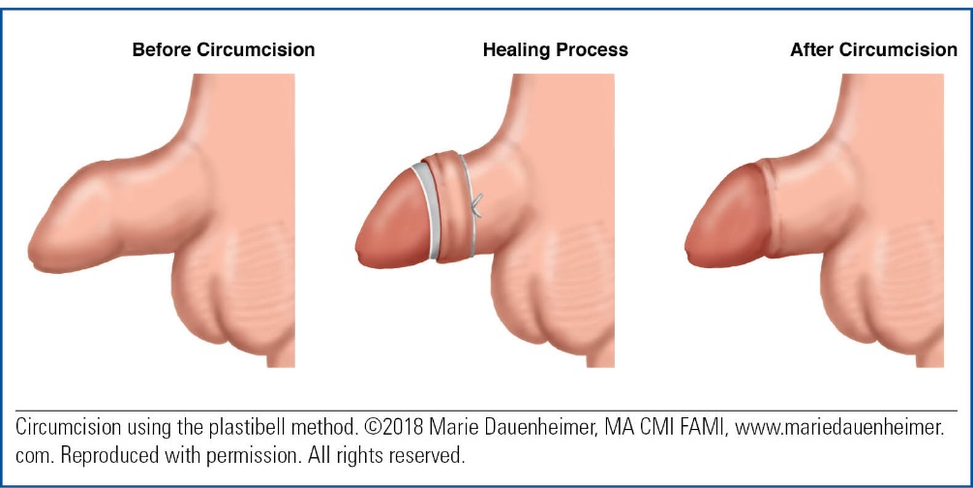

If the Plastibell method was used, the plastic ring should drop off within 5 to 8 days.

Call your baby’s provider or take him to the emergency room if

* the healing area starts to look worse
* your baby develops a fever
* your baby stops having wet diapers
* your baby stops eating or becomes inconsolable
* the area forms a yellowish discharge that can be easily wiped away and has a foul odor
* bleeding doesn’t stop after you apply pressure for 5 minutes
* the plastic ring doesn’t fall off within 5 to 8 days.

# Care of the Uncircumcised Penis

Wash around the penis with soap and water. Do not forcibly pull back on the foreskin. The foreskin will start to retract (pull back) on its own by 2 to 4 months of age. When the foreskin can easily be pulled back, wash the penis with soap and water.

The foreskin fully retracts around 3 years of age. At that time boys should be taught to wash underneath the foreskin every day.