Intraventricular Hemorrhage and Periventricular Leukomalacia: Information for Parents

Your baby is very weak, including the way that his or her brain is forming. Right now, your baby’s body is not able to control blood pressure changes in the same way that an older infant or adult body can. When the body can’t control blood pressure changes, sometimes a baby’s brain gets more blood than it needs, which can cause the vessels that carry the blood to rupture. When these vessels rupture, blood can build up inside your baby’s brain and cause what is known as an intraventricular hemorrhage (IVH). The term intraventricular refers to the inside of the brain. The term hemorrhage refers to bleeding. Both terms together mean there is bleeding inside the brain

There are different levels of bleeding in the brain with IVH. These levels also are called grades:

* Grade I means that there is a small bleed in the brain. Grade II means that there is a little more bleeding in the brain than Grade I, but it has not affected the inner part of the brain.
* Grade III means that there is bleeding that also has affected the inner parts of the brain. This includes the way that blood moves out of the brain.
* Grade IV means that there is more bleeding than in Grade III, and that the blood is pushing the brain against the bones of the head.

Periventricular leukomalacia (PVL) is different than IVH. *Periventricular* refers to the brain, whereas *leukomalacia* describes the way the baby’s brain looks. PVL occurs when not enough blood gets to some parts of the baby’s brain. These areas that have died leave little holes in the brain tissue (cysts). Babies with severe bleeding may develop a condition called posthemorrhagic hydrocephalus (PHH), which means the baby has a lot of fluid in the ventricles (where the bleeding was) or spaces in the brain. There may be so much fluid that it puts pressure on the brain tissue and may require a surgical procedure to drain the extra fluid.



Your baby’s provider will tell you if your baby has any bleeding in his or her brain (IVH) or if your baby has PVL. To test for IVH or PVL, your baby will need an ultrasound. An ultrasound is a painless test that uses a special wand with a jelly-like substance to take a video of your baby’s brain. These videos can be broken down into pictures that a doctor will look at. Your baby’s provider will then let you know the results of the test. Expect your baby to have an ultrasound after about a week of being in the hospital. Not all babies will have an ultrasound done. This is only done if your baby was born before 32–34 weeks. The ultrasound may be done again when your baby is close to 36 weeks gestation.



Your baby is at risk for bleeding in the brain because he or she was born early. Some other risks are if your baby had a low amount of oxygen during birth, had a low birth weight, or needs a machine to help with breathing.

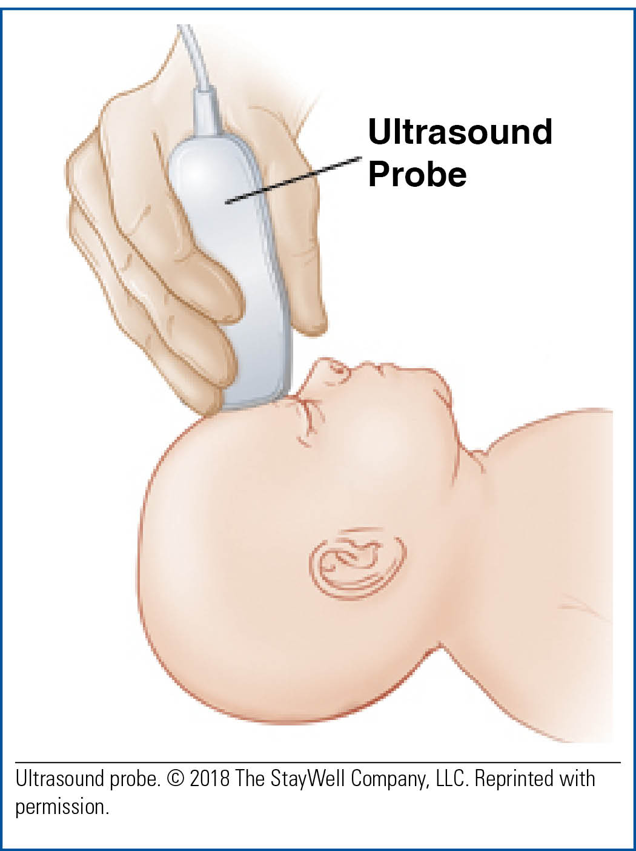

If your baby is diagnosed with IVH or PVL, the outcome will depend on how much of your baby’s brain is affected. Talk to your baby’s provider to find out what the future needs will be for your baby. It is hard for your baby’s providers to predict what will happen in the future for your baby, but it is important that you ask questions about any concerns that you have. Please ask your provider if you do not understand any part of the process of caring for your baby. It is OK to ask the same question more than once, so you get all the information you need to understand the diagnosis and treatment plan for your baby.