Chest Tubes: Information for Parents

Your baby has developed a collection of air or fluid in his or her chest that will require a chest tube to allow for drainage. This is a sterile procedure, and you may be asked to step away from the bedside so that a germ-free area can be maintained. Your baby will be given medication to control any pain during this procedure and will be monitored at all times. A tube will be placed between the lung and the chest wall. The chest tube may be introduced using a needle or by making a very small incision in the chest.
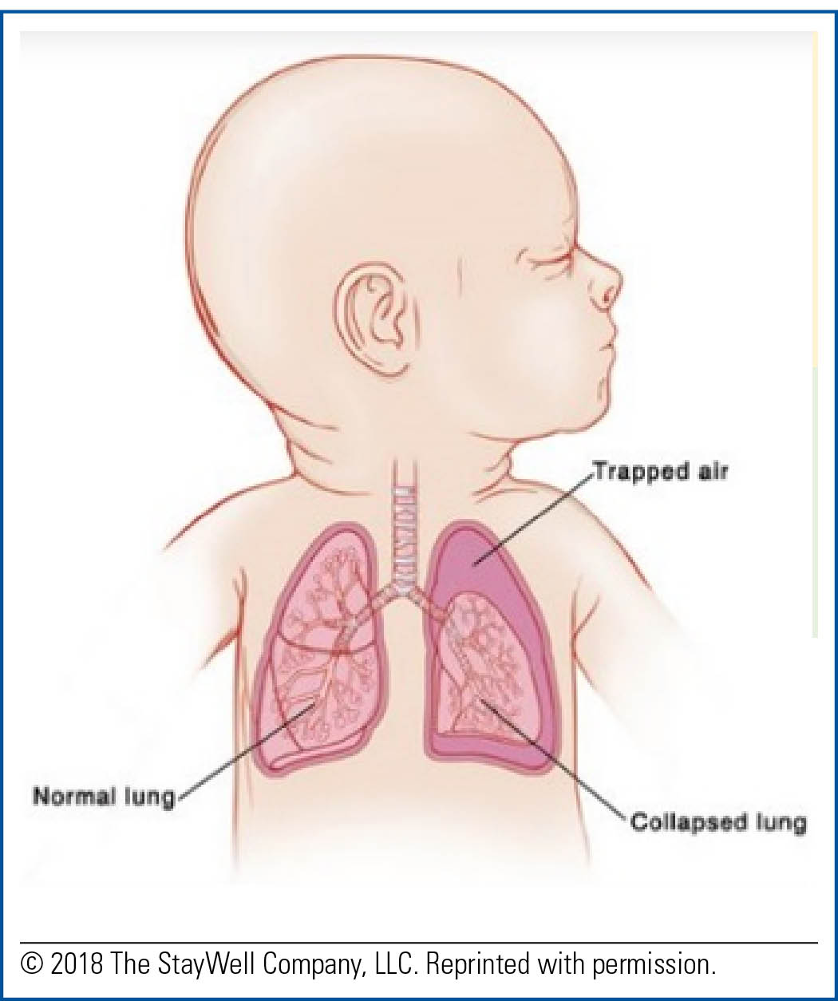

After the chest tube is in place, an X ray will be taken to make sure that the tube is in the right place and working well. A bandage will be placed over the chest tube site to protect it and keep the tube securely in place.
A drainage system will be attached to the chest tube to allow the medical team to monitor drainage and function of the tube. The attached tubing will be secured to the bed so that no pressure is placed on the tube. Please do not try to pick up or move your baby without assistance to stabilize this chest tube. Your baby will benefit from your touch, comfort, and presence at the bedside while this tube is in place.

Some problems associated with chest tube placement are bleeding and infection. Occasionally, the tube will need to be replaced due to plugging by fluid or blood. Other problems, including injury to the lung, breast tissue, and other structures in the chest, are very rare.

The length of time the chest tube will be in place is determined by how long it is needed for drainage. Once drain- age appears to be decreasing, the medical team will make a plan for when they can safely remove this tube.

While the tube is in place, your baby will be given pain medication as needed to ensure that he or she is comfortable. Your baby might need to be positioned in a certain way to assist with proper drainage. Most babies heal quickly after the tube is removed, but they may have a small scar where it was placed.

