Hydrops Fetalis: Information for Parents

Your baby has been diagnosed with a condition referred to as hydrops fetalis—meaning the abnormal accumulation of fluid in the baby’s soft tissues, organs, and cavities. There are two types of hydrops fetalis: immune and nonimmune. Neither of these conditions are related to something that the mother has done; said another way, there is nothing she could have done to prevent either of these conditions.
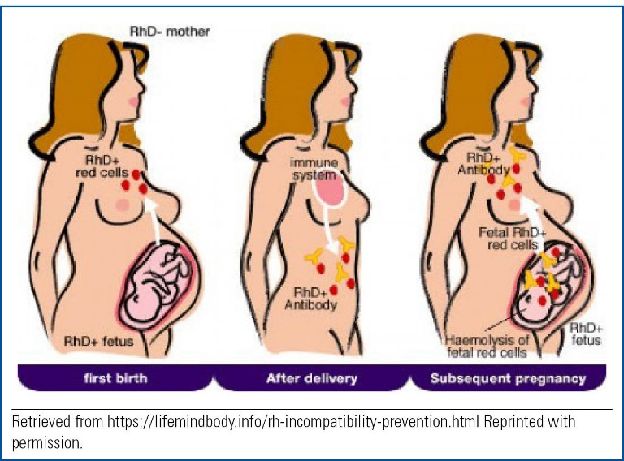

Immune hydrops fetalis (IHF) results when the mother’s immune system sees the baby’s red blood cells as dangerous and starts to break them down. This is called alloimmunization. Alloimmunization occurs when a mother with a negative blood type is pregnant with a baby whose blood type is positive. The Rh antigen is an inherited protein found on the red blood cells. If the protein is present, then the person is Rh+. A negative blood type does not have the Rh antigen attached to it, so when the mom’s blood and the baby’s blood come in contact with each other, the mom’s blood cells mount an immune response. An immune response happens when the cells of the body do not recognize the foreign cells (Rh antigen) and try to rid the body of any danger from the foreign cells. This is the same response that would happen if an infection was present. When the immune response is triggered, the mother’s blood cells begin fighting the baby’s blood cells and start making antibodies against them. It takes a very small amount of baby’s blood (about a drop or two) to get into a mother’s bloodstream to cause this antibody reaction. Usually during pregnancy a mother’s blood and baby’s blood do not mix. Mixing can occur if there is a leak in the placenta, which is very rare. Mixing can occur until birth.

Alloimmunization can occur with any pregnancy, not just your first. You might not be aware of the blood type issue the first time it happens, so after the baby is born, you will receive a shot called RhoGAM®. RhoGAM®, or Rho (D) immunoglobin, is given to Rh-negative mothers after they give birth to a Rh-positive baby. Then, it is given as a preventative to all Rh-negative mothers during each subsequent pregnancy between 26 and 28 weeks gestation. Before the invention of RhoGAM® in the 1960s, this condition occurred in 10% of all pregnancies. Today, it is a very rare occurrence.

Nonimmune hydrops fetalis (NIHF) accounts for about 90% of all nonalloimmunization cases. Unfortunately, in most cases, the cause for the hydrops is unknown. In the babies where a cause is found, it will typically be related to an issue with the baby’s heart or genetic or chromosome problems that affect the baby. Overall, 60% of the cases of NIHF are diagnosed prenatally.

NIHF results when a disease or complication during pregnancy causes the baby’s blood cells to be continually broken down, which causes severe chronic anemia. Anemia means that there aren’t enough red blood cells circulating in the body to carry oxygen. When this happens, the body tries to compensate by making the heart and other organs work harder to get the blood through the body. However, it eventually tires out and extra fluid starts to build up in one or more of the following places: under the skin, in the lungs, and in the heart.

Symptoms of NIHF
While each baby’s experience will differ, common symptoms seen at a prenatal ultrasound may include
- two or more abnormal areas of fluid collection in the fetus
- ascities, or swelling around the abdominal area
- fluid present in the lungs or around the heart
- generalized skin swelling of greater than 5 mm.

One symptom mothers may experience during pregnancy is a large amount of amniotic fluid. This is called polyhydramnios. Symptoms that can be seen after the baby is born include
- difficulty breathing and needing some type of oxygen therapy
- pale coloring
- severe skin swelling overall, especially in the abdominal area
- an enlarged liver or spleen seen on ultrasound or X ray
- fluid collection in either one or both lungs as seen on ultrasound or X ray
- fluid collection in the sac around the heart as seen on ultrasound or X ray.

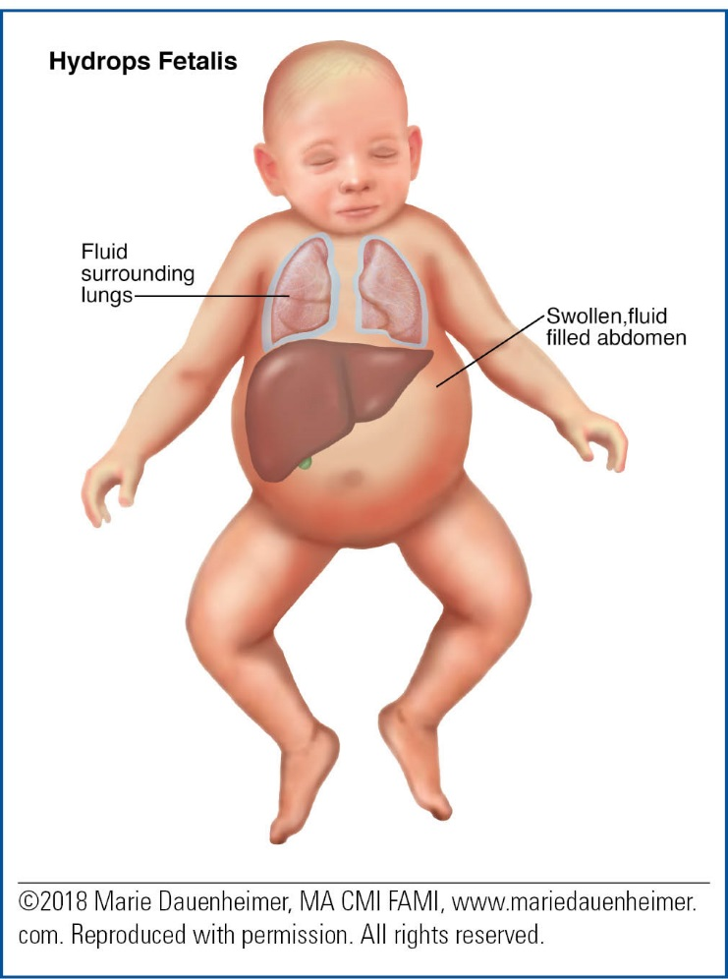

Treatment Options
There are many treatments for NIHF. The treatment your baby gets will depend on many different factors, including your baby’s gestational age, your pregnancy history, severity of the condition, and how your baby tolerates different medications and procedures.

Treatments that might be used to help your baby include
- using supplemental oxygen to help with breathing. Oxygen can be delivered in many ways. It can be given by a cannula placed in the nose or by a mechanical breathing machine (ventilator) with a breathing tube.
- removal of the extra fluid from the spaces around the lungs, heart, or abdomen
  - Thoracentesis is removal of air or fluid from around the lungs.
  - Paracentesis is removal of fluid from the abdominal area.
  - Paracardiocentisis is removal of fluid from the sac around the heart.
- X rays and ultrasounds
- blood draws to check on the baby’s chromosomes.

Surgery is usually not needed. However, surgical procedures such as thoracentesis, paracentesis, and paracardiocentis may be performed in the neonatal intensive care unit.

Long-Term Implications
The long-term outcome for babies born with NIHF varies. Of all the cases that are diagnosed during pregnancy, only about 20% will survive to delivery. Approximately half of these babies will die during the first month of life; however, research is showing that the outlook for babies who do survive is very optimistic.

In summary, NIHF is a very serious complication during pregnancy and immediately after birth. However, there are many treatment options that the neonatologist or nurse practitioner will discuss with you. It is important for you to keep notes of your discussion and write down any questions you have. The whole healthcare team wants you to understand the plan of care and to be involved in the decision-making process for your baby.

Resource
The American College of Obstetrics and Gynecology. Rh Factors: How it can affect your pregnancy.
Retrieved from www.acog.org/Patients/ FAQs/The-Rh-Factor-How-It-Can-Affect-Your-Pregnancy#what

