|  |  |  |  |
| --- | --- | --- | --- |
|  |  |  |  |

Neonatal Seizures: Information for Parents

The brain is made up of millions of nerve cells, all connected together, that create and receive signals. These signals control many functions of our body. A seizure can occur when there is a disruption in the communication between brain nerve cells, which alters the signals or causes them to not fire as they should.

Neonatal seizures are seizures in a baby who is less than 28 days old or in a preterm baby who is less than 44 weeks adjusted age. Neonatal seizures are different from seizures in older children and adults. Babies are at higher risk for having seizures because their brain is immature and still developing. Neonatal seizures can be caused by many different things, and just because your baby has seizures now does not mean that your baby will have seizures later in life.

Some causes of seizures in your baby include

* a decrease or lack in oxygen or blood flow to your baby’s brain before or during birth
* an infection caused by certain bacteria or viruses, before or after birth, that can cause meningitis or encephalitis
* bleeding in or around the brain
* brain structure abnormalities
* abnormal metabolic or electrolyte levels, including low blood sugar, low calcium, and low or high sodium
* problems in the body’s chemistry or metabolism
* family history of seizures or “fits”
* drug withdrawal, which may be seen in infants born to mothers using barbiturates, alcohol, heroin, cocaine, methadone, painkillers, or other substances.

Neonatal seizures do not usually last long and it may be hard to tell if your baby is actually having a seizure. Seizures in a newborn can include any of the following behaviors:

* change in facial movements (repeated movements of the eyes, lips or tongue)
* movements of the arms or legs that look like riding or pedaling a bike
* staring
* stopping breathing
* rhythmic jerking
* stiffening or tightening of arms or legs
* quick jerks involving legs, arms, or the whole body.

Newborn babies can have a variety of different movements that might look like seizures but are not. Some examples are simple things, like sucking and stretching, or jitteriness when they are crying or disturbed. The jitteriness should diminish over the first few weeks after birth and should be less frequent when the baby is quiet and awake. Other babies have single jerks of their arms or legs during sleep. This is called *benign neonatal sleep myoclonus* and should stop when the baby wakes up.

Both of these example are not concerning and do not need any treatment.

So how do you recognize seizures in your baby? Look for movements that the baby repeats over and over and are not provoked, or if your baby seems to be staring or not present during these movements. Many times these movements will occur in clusters for a short period of time. If you are unsure, try to video the movements to show your healthcare provider.

If seizures are suspected, it is important to monitor your baby’s brain waves and function of the nerve cells using an electroencephalogram (EEG). An EEG can show how the brain cells are talking to each other and if there is

a problem. Wires and gentle “paste” are used to hold electrodes to the baby’s skin. It is not a painful procedure.

These electrodes then send wavy lines to a machine to graph the impulses, and the graphs tell the providers if something is abnormal and if there are seizures occurring. During an EEG recording, you may notice many different waves and changes on the screen—these do not always represent abnormal brain activity. Some changes may result from movement of the head or stimulation. Heart rate and oxygen level changes will be monitored, as these may be associated with seizures.

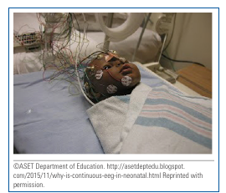

If your baby is having seizures, it may be necessary to do other tests such as blood work, magnetic resonance imaging (MRI), or computed tomography (CT) scan to determine the cause of the seizures.

There is evidence that seizures may affect the brain function and development, so it is important to identify and control the seizures. Your baby’s healthcare team will look for the cause of the seizures and treat them as needed. The healthcare team will first try to correct any abnormalities of blood sugar or electrolytes (other normal substances in our body). If the seizures continue, your baby may need an antiepileptic drug (a drug to treat and stop the seizures).

Phenobarbital is the first drug of choice to treat neonatal seizures. Sleepiness is one of the major side effects and may be observed, especially in the first days of treatment. If the seizures are not controlled with this medication, there are others that can be added. Often, newborns that have seizures only need medication for a short time. Many times, the medication is stopped before

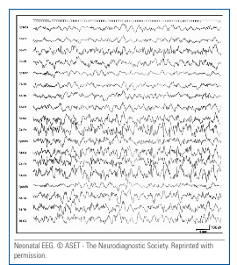

going home. If your baby still needs medication at home, your baby will need to be monitored by a neurologist (pediatrician who specializes in the brain and spinal cord) as an outpatient.

If your baby is diagnosed with neonatal seizures, the outcome may be different depending on the cause of the seizures. Talk to your baby’s healthcare providers to find out what the future effects will be for your baby. If your baby’s seizures are caused by an underlying brain injury or abnormality, his or her long-term outcome may be more serious. It is important to provide the healthcare team with as much information as possible regarding family history (especially of seizures or “fits”), birth history, and prenatal history. This may help the healthcare team identify a cause for the seizures and give more information to guide treatment and improve outcome expectations.