# Temperature Control: Information for Parents

Babies can sometimes have a hard time keeping their temperature in the normal range. Full-term babies have a layer of fat under their skin that helps them stay warm. When babies are born early they don’t have as much fat under their skin.

Right after birth, your baby can get cold very quickly. The best way to keep your baby warm is to dry your baby; give your baby a warm, dry bed; and place a hat on his or her head.



In the neonatal intensive care unit (NICU), one of the beds that can be used is called a radiant warmer. It is like an open crib, with a heater on it that helps your baby stay warm. Another bed your baby may use is called an isolette or incubator. This gives a preemie or sick baby extra heat to help keep his or her temperature where it should be.

When your baby is older and bigger, he or she can be dressed in clothes or a T-shirt, wrapped in a blanket, and put in an open crib or bassinet. This is one of the milestones along the journey to home.

It also is important to make sure your baby doesn’t get too warm. Dressing your baby in too many clothes, covering your baby in too many blankets, or covering your baby’s face can make him or her too warm. For more information related to this subject, see Safe Sleep in Step 6.

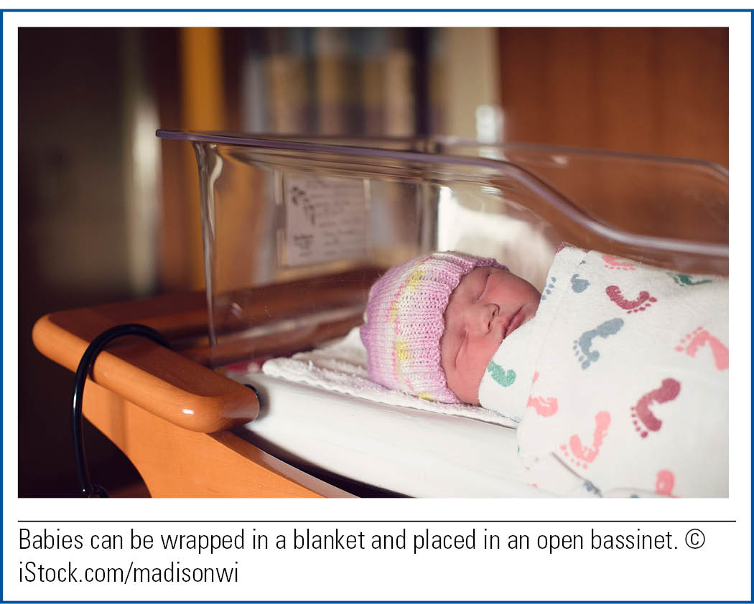

Things to remember when going home:

• If your baby’s body temperature is lower than 97 °F (36 °C), undress your baby, place him or her skin to skin on your chest, wrap yourselves in blankets, and call your baby’s provider. You also should call the provider if your baby’s temperature is higher than 100.4 °F (38 °C).

• If your baby’s hands or feet are cool or look pale or blue, warm them with a blanket. You also can add a layer of clothing. If the color of your baby’s hands and feet does not improve, call your baby’s provider.

• Dress your baby in layers. To avoid overheating, add only one more layer of clothing than you are wearing if the temperature is cool, and remove a layer of clothing if your baby is warm. Use sleepers when you can.

• Remove clothes when they are wet or dirty.



• Keep your baby away from drafts and windows as much as possible.

• Keep the crib away from drafts, windows, and outside walls by placing your baby’s crib on the inner wall of the room.

• Always place a hat on your baby when you go outside in cool or windy weather.